To: Department Heads
Fm: You
Re: Content For Website
Date:
Adding fresh, quality content on a regular basis to our websites is a huge part of our success here at Your Company. According to our SEO Mike Munter, “Content is king” with Google and he believes it is a critical part of our improved traffic, rankings, and lead generation.
Since we began tracking our website traffic in October 2011, we’ve seen a three-fold increase in the number of visitors to our website. Every visitor to our site is a potential lead that we are getting and our competitors are not getting .
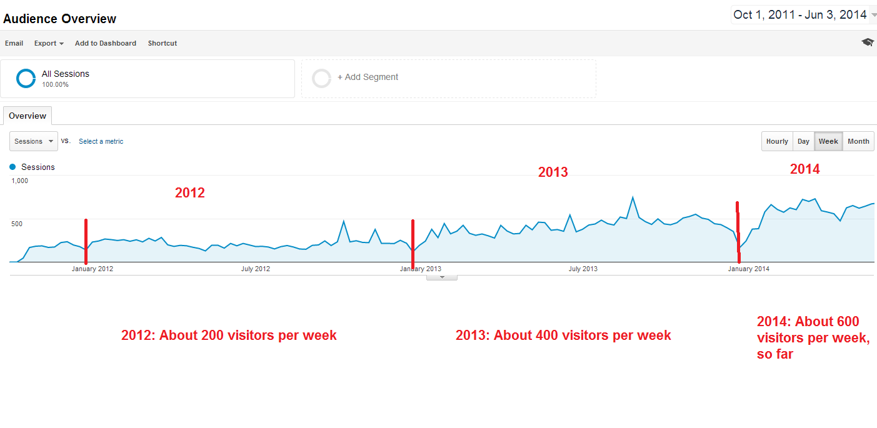
What This Means To You
So far, you all have done a great job of making time to provide content when I remind you. What you send to me usually gets forwarded to Mike for publication on our site, sharing in our social media channels, and promotion in our monthly newsletter.
Going forward, I am turning over to Mike Munter the responsibility of reminding each of you to provide content each month. Mike will send you a friendly reminder via email once per month and also provide you with guidance on topics for you to write about.
As more and more people use Google to find an IVF clinic to work with, our website continues to be an important 24/7/365 salesperson we rely on to attract new business. I appreciate your helping us keep our site updated with rich, quality content that will continue to set us apart from the competition!

